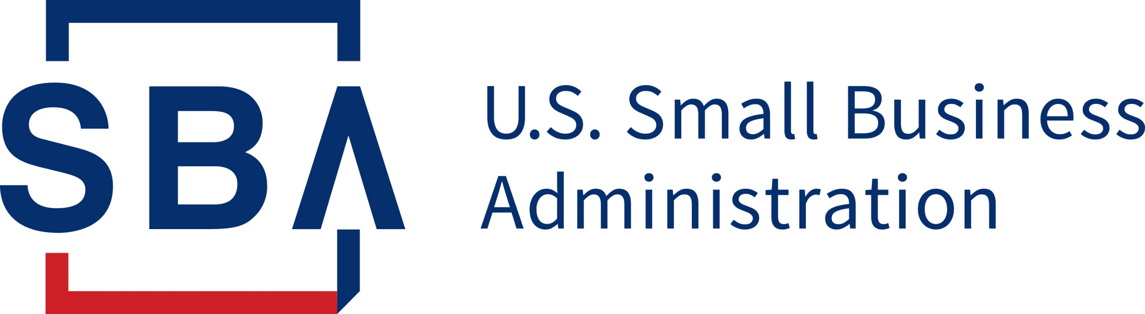

Eligibility of Agricultural Related Industries

Cares Act Paycheck Protection Program Eligibility: (https://www.appropriations.senate.gov/imo/media/doc/FINAL%20FINAL%20CARES%20ACT.pdf)

‘‘(i) IN GENERAL.—During the covered period, in addition to small business concerns, any business concern, nonprofit organization, veterans organization, or Tribal business concern described in section 31(b)(2)(C) shall be eligible to receive a covered loan if the business concern, nonprofit organization, veterans organization, or Tribal business concern employs not more than the greater of— ‘‘(I) 500 employees; or ‘‘(II) if applicable, the size standard in number of employees established by the Administration for the industry in which the business concern, nonprofit organization, veterans organization, or Tribal business concern operates.”

SBA Paycheck Protection Program Interim Final Rule Eligibility: (https://www.sba.gov/sites/default/files/2020-04/PPP%20Interim%20Final%20Rule_0.pdf)

“You are eligible for a PPP loan if you have 500 or fewer employees whose principal place of residence is in the United States, or are a business that operates in a certain industry and meet the applicable SBA employee-based size standards for that industry, and You are: A small business concern as defined in section 3 of the Small Business Act (15 U.S.C. 632), and subject to SBA’s affiliation rules under 13 CFR 121.301(f) unless specifically waived in the Act; or B. A tax-exempt nonprofit organization described in section 501(c)(3) of the Internal Revenue Code (IRC), a tax-exempt veterans organization described in section 501(c)(19) of the IRC, Tribal business concern described in section 31(b)(2)(C) of the Small Business Act, or any other business; and ii. You were in operation on February 15, 2020 and either had employees for whom you paid salaries and payroll taxes or paid independent contractors, as reported on a Form 1099–MISC. You are also eligible for a PPP loan if you are an individual who operates under a sole proprietorship or as an independent contractor or eligible selfemployed individual, and you were in operation on February 15, 2020. You must also submit such documentation as is necessary to establish eligibility such as payroll processor records, payroll tax filings, or Form 1099–MISC, or income and expenses from a sole proprietorship. For borrowers that do not have any such documentation, the borrower must provide other supporting documentation, such as bank records, sufficient to demonstrate the qualifying payroll amount. SBA intends to promptly issue additional guidance with regard to the applicability of affiliation rules at 13 CFR 121.103 and 121.301 to PPP loans.”

Small Business Act, Section 3: (https://www.law.cornell.edu/uscode/text/15/632)
“For the purposes of this chapter, a small-business concern, including but not limited to enterprises that are engaged in the business of production of food and fiber, ranching and raising of livestock, aquaculture, and all other farming and agricultural related industries, shall be deemed to be one which is independently owned and operated and which is not dominant in its field of operation.”

U.S. Department of Treasury Frequently Asked Questions Guidance: (https://home.treasury.gov/system/files/136/Paycheck-Protection-Program-Frequently-Asked-Questions.pdf)
“Question: Are small business concerns (as defined in section 3 of the Small Business Act, 15 U.S.C. 632) required to have 500 or fewer employees to be eligible borrowers in the PPP? Answer: No. Small business concerns can be eligible borrowers even if they have more than 500 employees, as long as they satisfy the existing statutory and regulatory definition of a “small business concern” under section 3 of the Small Business Act, 15 U.S.C. 632. A business can qualify if it meets the SBA employee-based or revenue based size standard corresponding to its primary industry. Go to www.sba.gov/size for the industry size standards. Additionally, a business can qualify for the Paycheck Protection Program as a small business concern if it met both tests in SBA’s “alternative size standard” as of March 27, 2020: (1) maximum tangible net worth of the business is not more than $15 million; and (2) the average net income after Federal income taxes (excluding any carry-over losses) of the business for the two full fiscal years before the date of the application is not more than $5 million. A business that qualifies as a small business concern under section 3 of the Small Business Act, 15 U.S.C. 632, may truthfully attest to its eligibility for PPP loans on the Borrower Application Form, unless otherwise ineligible.”

Are Agricultural producers, farmers, and ranchers with 500 or fewer employees whose principal place of residence is in the United States eligible?
Yes, farms are eligible if: (i) the farm has 500 or less employees, OR (ii) it fits within the revenue-based sized standard. OR farms can qualify for PPP if it meets SBA’s “alternative size standard.” The “alternative size standard” is currently: (1) a maximum net worth of the business not more than $15 million, AND (2) the average net income Federal income taxes of the business for the two full fiscal years before the date of the application be not more than $5 million.

